Christ’s Reformed Church – United Church of Christ
~ growing people of faith who live in Jesus, love one another and bear abundant fruit ~
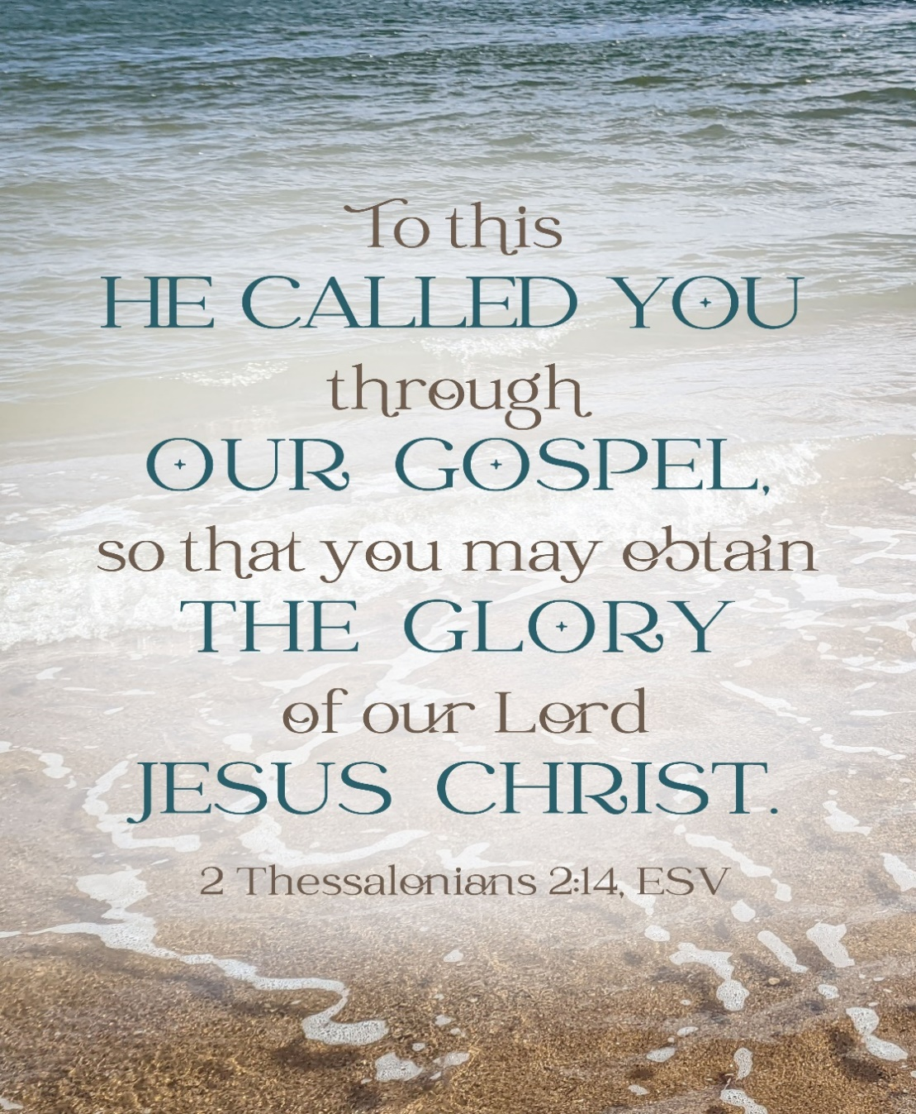
Twenty-Second Sunday after Pentecost
November 9, 2025
(*Please Stand in body or in spirit.)
Prelude Faith of our Fathers

Welcome and Announcements

Special Music Martin Fisher

Call to Worship
Guard me as the apple of your eye, O God.
You wondrously show us your steadfast peace
Hide me in the shadow of your wings, Divine Spirit.
You wondrously show us your steadfast strength.
I behold your face in righteousness, Christ of Hope.
You wondrously show us your steadfast love.

Invocation
God of Love, Divine Traveler,
We see only a fraction of your presence, God. We know you only in part, as we experience this world with our senses, our experiences, and what is tangibly in front of us. How does the sacredness of each earthly breath draw us closer to your presence on this side of Heaven? May we grasp the beauty of this world, even on the gloomy days. May we cherish our relationships here on earth even when times are challenging. May we know that God is forever present with us and will care for us as we arrive at our eternal home on the other side of Heaven. Amen.

*Hymn Come, Ye Faithful Raise the Strain Red hymnal #169

Prayer of Confession/Transformation
God of the Heavenly Winds and Earthy Air,
So often, we concern ourselves about the afterlife. We wonder who will be there, what we need to believe, and more. Yet, on this side of heaven, in your earthly Realm, there are many still hurting from the pains accumulated in this life. From illnesses to poverty, and from the lack of kindness to the overwhelming injustices, we overlook the needs of our siblings. Open our hearts to the gaps happening in our world. Allow us to be more compassionate and less judgmental about our neighbors who need additional help. Help us to set aside our worries about the afterlife as we know you will care for us there and then. (time of silence) Amen.

Words of Assurance
Even when we are overwhelmed by our thoughts of life after death, God shares hope. May God’s grace transform us here in this world as we build the Realm of God here on earth. Amen.

Prayer of Illumination (singing) Sanctuary (Lord Prepare Me)
Lord prepare me to be a sanctuary, pure and holy tried and true. With thanksgiving, I’ll be a living sanctuary for you.
Hearing the Word of God
Older Testament Job 19:23-27
²³ “O that my words were written down!
O that they were inscribed in a book!
²⁴ O that with an iron pen and with lead
they were engraved on a rock forever!
²⁵ For I know that my vindicator lives
and that in the end he will stand upon the earth;
²⁶ and after my skin has been destroyed,
then in my flesh I shall see God,
²⁷ whom I shall see on my side,
and my eyes shall behold, and not another.
My heart faints within me!

Newer Testament 2 Thessalonians 2:1-5, 13-17
As to the coming of our Lord Jesus Christ and our being gathered together to him, we beg you, brothers and sisters, ² not to be quickly shaken in mind or alarmed, either by spirit or by word or by letter, as though from us, to the effect that the day of the Lord is already here. ³ Let no one deceive you in any way, for that day will not come unless the rebellion comes first and the lawless one is revealed, the one destined for destruction. ⁴ He opposes and exalts himself above every so-called god or object of worship, so that he takes his seat in the temple of God, declaring himself to be God. ⁵ Do you not remember that I told you these things when I was still with you?
¹³ But we must always give thanks to God for you, brothers and sisters beloved by the Lord, because God chose you as the first fruits for salvation through sanctification by the Spirit and through belief in the truth. ¹⁴ For this purpose he called you through our gospel, so that you may obtain the glory of our Lord Jesus Christ. ¹⁵ So then, brothers and sisters, stand firm and hold fast to the traditions that you were taught by us, either by word of mouth or by our letter.

Gospel Lesson Luke 20:27-38
²⁷ Some Sadducees, those who say there is no resurrection, came to him ²⁸ and asked him a question: “Teacher, Moses wrote for us that if a man’s brother dies leaving a wife but no children, the man shall marry the widow and raise up children for his brother. ²⁹ Now there were seven brothers; the first married a woman and died childless; ³⁰ then the second^{[c]} ³¹ and the third married her, and so in the same way all seven died childless. ³² Finally the woman also died. ³³ In the resurrection, therefore, whose wife will the woman be? For the seven had married her.”
³⁴ Jesus said to them, “Those who belong to this age marry and are given in marriage, ³⁵ but those who are considered worthy of a place in that age and in the resurrection from the dead neither marry nor are given in marriage. ³⁶ Indeed, they cannot die anymore, because they are like angels and are children of God, being children of the resurrection. ³⁷ And the fact that the dead are raised Moses himself showed, in the story about the bush, where he speaks of the Lord as the God of Abraham, the God of Isaac, and the God of Jacob. ³⁸ Now he is God not of the dead but of the living, for to him all of them are alive.”

The word of God for the people of God
Thanks be to God.

Sermon Rev. Mary Jane Norville

*Hymn Standing on the Promises

Prayers of the People – Psalm 17:1-9

The Lord’s Prayer
Our Father in heaven: May your holy name be honored; ¹⁰ may your Kingdom come; may your will be done on earth as it is in heaven. ¹¹ Give us today the food we need. ¹² Forgive us the wrongs we have done, as we forgive the wrongs that others have done to us. ¹³ Do not bring us to hard testing, but keep us safe from the Evil One.’ For yours is the kingdom, and the power, and the glory forever. Amen. (Good News Bible)

Offering

Invitation to Generosity
We have our minds set to our time after this life. Yet God is calling us to care for our communities and churches here on this side of Heaven. May we name the ways we can create Heaven on earth for our neighbors. By using our talents, treasures, and time, may we seek to build safety and sanctuary for all of God’s children.

Offertory God Leads Us Along

*Doxology
Praise God from whom all blessings flow, praise God all creatures here below. Praise God for all that love has done; Creator, Christ, and Spirit, One. Amen.

*Prayer of Thanksgiving and Dedication
God of Infinite Love,
Through our gifts, we create glimmers here on this side of Heaven. Through our treasures, time, and talents, we nurture your Realm. We provide for our neighbors who lack basic necessities and who look for inclusion of their souls. May Heaven be a place that we can experience throughout our lives as we breathe the invigorating air of your Spirit. With gratitude, we celebrate our gifts from you and dedicate our gifts to bring peace to this earth. Amen.

*Hymn How Great Thou Art

*Benediction
As we abide together on this side of Heaven,
May the Christ of Hope lead us to righteousness and justice,
May the Spirit of Strength fill our hearts with courage,
May God, our Joyful Creator, graciously settle our hearts with peace.
May we find ourselves on journeys seeking glimmers of paradise and the presence of the Divine among us. Amen.

*Benediction In Song Let There Be Peace on Earth
Let there be peace on earth
And let it begin with me
Let there be peace on earth
The peace that was meant to be.
With God as creator
We are family
Let us walk with each other
In perfect harmony.
Let peace begin with me
Let this be the moment now.
With every step I take
May this be my solemn vow.
To take each moment and live
Each moment in peace eternally
Let there be peace on earth
And let it begin with me.

*Postlude Passing of the Peace.



The altar flowers are placed in honor of our family members who are Military Veterans- Dave Eichelberger, George Kline, Denny Eichelberger and Alan Eichelberger. Active duty—Darrin Eichelberger and Derek Eichelberger.

Thank you to the many men and women who have served or are actively serving, thank you for your service.

 |  | Welcome to our Guests: We gather to praise “the Lamb of God, who takes away the sin of the world!” (John 1:29). Because of Jesus, you can be at peace in the assurance of God’s forgiveness and love. Welcome to worship!! If you have come as a visitor, we hope that you’ll leave as a friend who’s been blessed by worshiping in this house of God. We look forward to seeing you again.
November Events
Change 4 Change: Veterans Care
9 171 Anniversary and Veterans Acknowledgment, Cathedral On Fire Discussion Time, Chapters 2 & 3,
choir practice
10 Consistory, 9:30am
16 Rae Smith (From Zion) will be preaching. Reach Week begins, Please see Martin or Kathy Fisher if
you can help. Discussion Time Chapter 4
23 Thanksgiving Sunday and Reign of Christ
27 & 28 Thanksgiving, Church office closed
30 Hanging of the Greens

Liturgist:  Altar Preparation:  Ushers:  Van Driver  November 16 Liturgist  Van Driver | Charlotte Trout  Donna Stockslager  Jim Morris, Bob Barkdoll, Steve Lohr, Faye Metz, Dave Engle  Martin Fisher  Gene Jones  Mike McCauley
Stewardship Report
Approved by Consistory 10/13/25

Financials for September 2025 Samaritan Fund balance $934.88
September 2025  Offerings $8,551.53 | YTD Jan – September 2025  Offerings $70,113.06
ATS Repayment $ 4000.00 | ATS Repayment $18,000.00
Endowment Fund $10,000.00 | Endowment Fund $120,000.00
Other $1,328.45 | Other Income $19,543.42
Total Income $23,879.98 | Total Income $227,656.48
Expenses $26,596.42 | Expenses $244,517.47
Net Profit/Loss ($2,716.44) | Net Profit/Loss ($16,860.99)

Christ's Reformed Church  Phone No: 301-733-4144  Fax No. 301-733-4145  Church General email: crc1854@myactv.net  Website: www.crcucc.org  Morning Worship 9:30 am  YouTube: CRC Christ’s Reformed Church |  | Church Staff  Pastor: Rev. Mary Jane Norville  Email: reverend.norville@gmail.com  Office and Communication Support Associate:  Jenny Kelley Email: jennykelley@myactv.net  Organist: Brent Johnson  Tech. Support:  Custodian: Margaret Bussard  Bookkeeper : Denise Kelly  Consistory President : Steve Lohr  ATS President: Charlotte Trout

